- Install nginx and run nginx on port number 81.
sudo apt update
sudo apt install nginx -y
sudo yum install epel-release -y
sudo yum install nginx -y
Change Nginx Port to 81:
sudo nano /etc/nginx/sites-available/default
- OR main config file:
sudo nano /etc/nginx/nginx.conf
listen 81;
Test and restart Nginx:
sudo nginx -t
sudo systemctl restart nginx
Allow port 81 in firewall:
sudo ufw allow 81/tcp

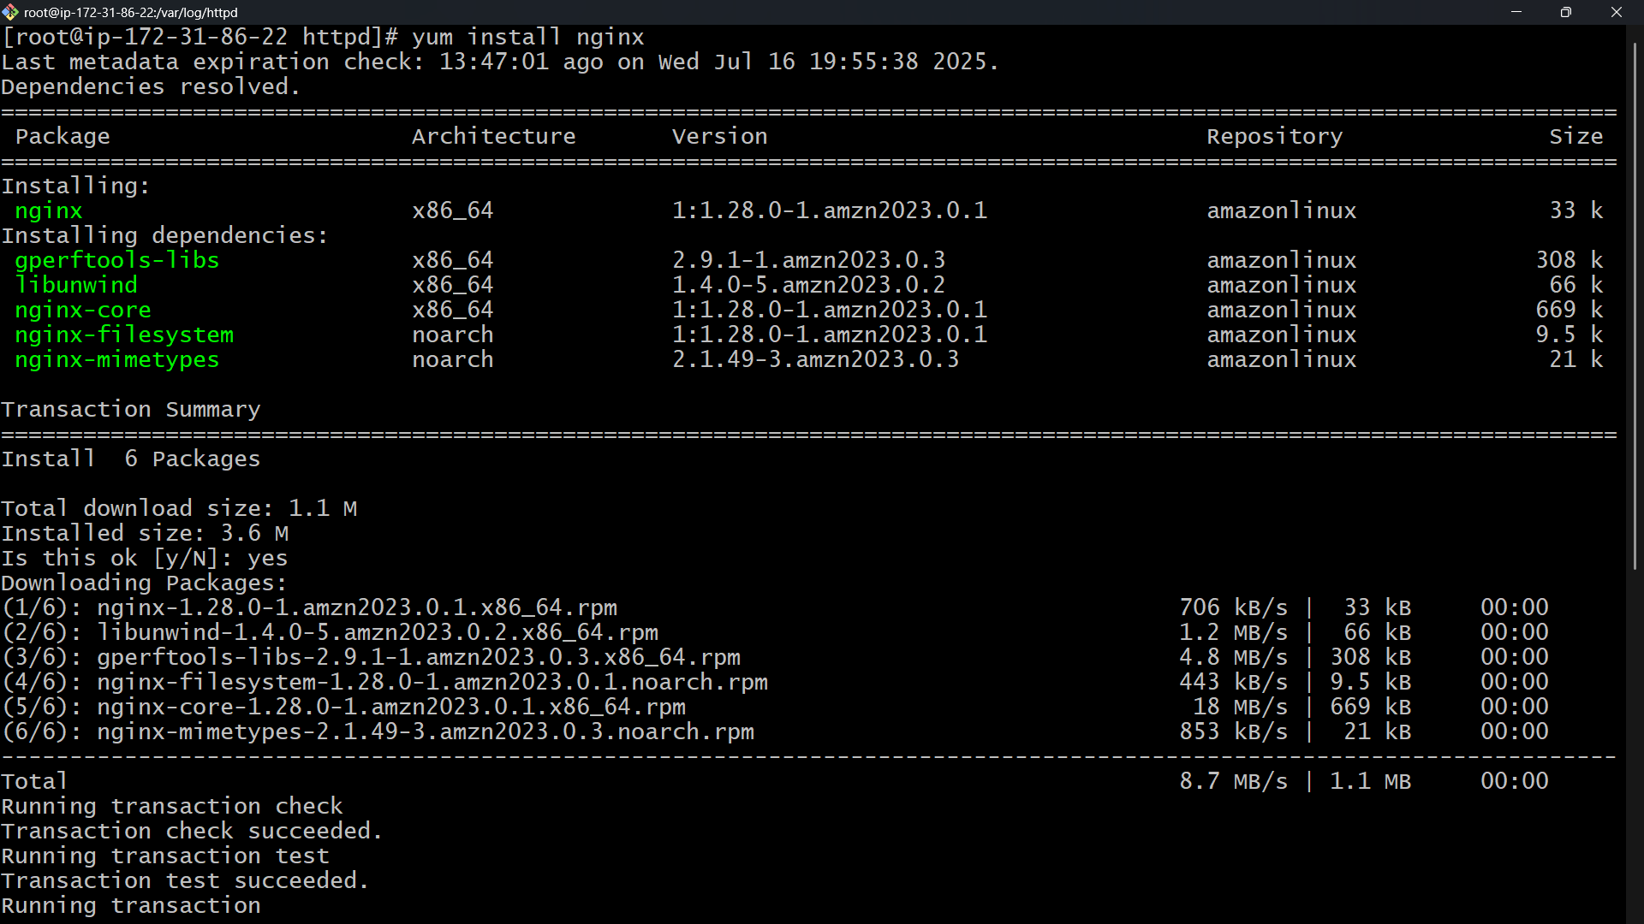
2) Deploy a sample index.html file on nginx.
Nginx default directory:
/var/www/html
Replace or create index.html:
sudo nano /var/www/html/index.html
Add:
<h1>Welcome to Nginx on port 81!</h1>
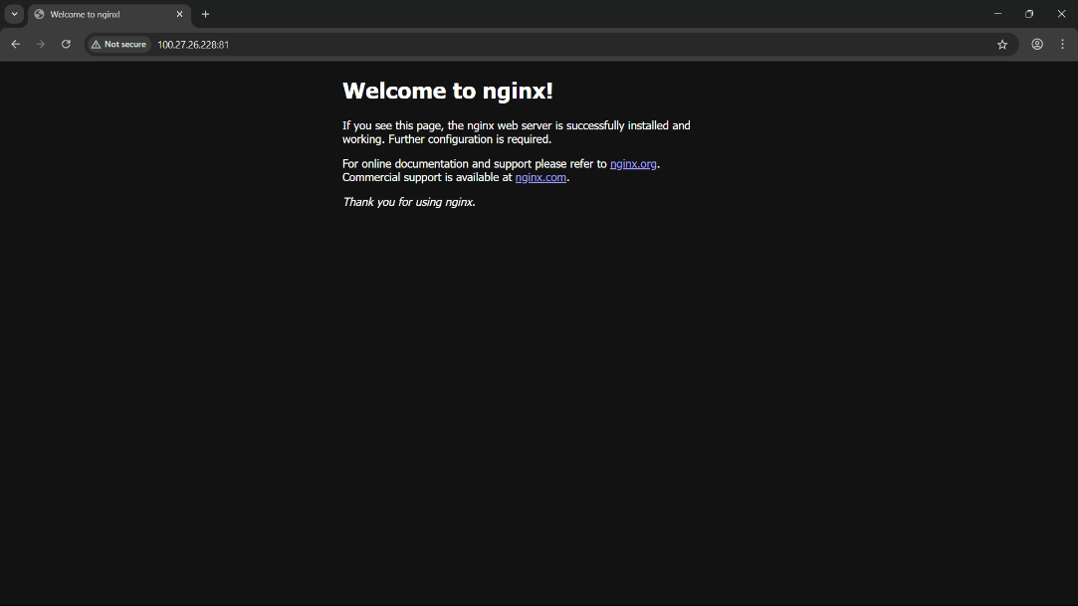

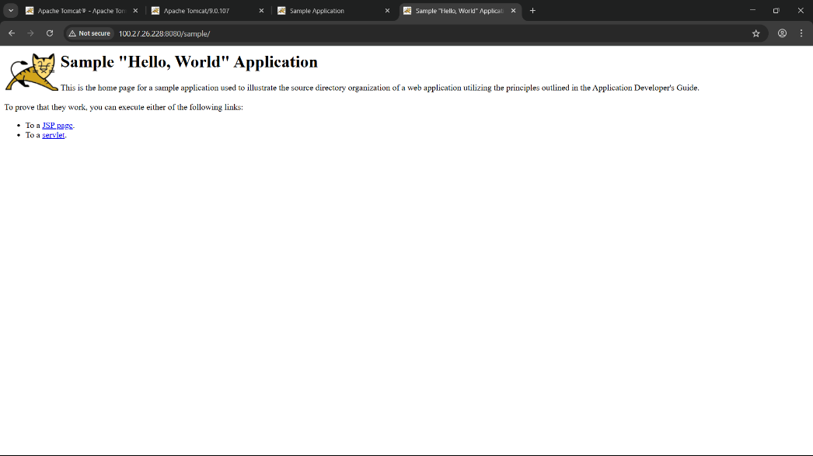
3) Deploy a sample index.html file on Apache.
Apache default directory:
/var/www/html
Create
sudo nano /var/www/html/index.html
Add:
<h1>Muhammad Waseem </h1>


5) Install Apache tomcat on port number 8082
Download Tomcat:
cd /opt
sudo wget https://downloads.apache.org/tomcat/tomcat-10/v10.1.20/bin/apache-tomcat-10.1.20.tar.gz
sudo tar -xvzf apache-tomcat-10.1.20.tar.gz
sudo mv apache-tomcat-10.1.20 tomcat
Change port to 8082:
sudo nano /opt/tomcat/conf/server.xml
Find
<Connector port="8080" protocol="HTTP/1.1"
Change to:
<Connector port="8082" protocol="HTTP/1.1"
Start Tomcat:
cd /opt/tomcat/bin
sudo chmod +x *.sh
./startup.sh
Check:
http://<server-ip>:8082
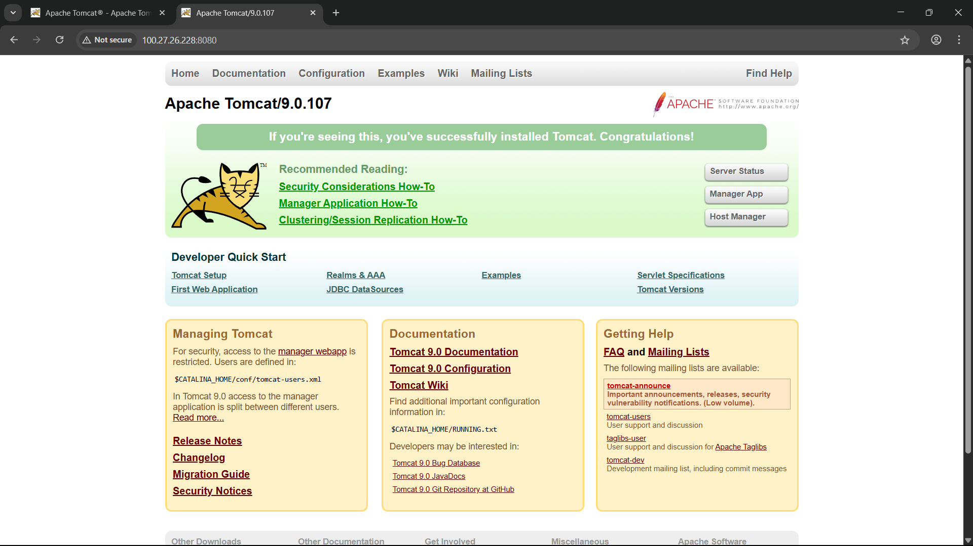
6) Deploy a sample app on webapps

Deploy a sample WAR file:
cd /opt/tomcat/webapps
sudo wget https://tomcat.apache.org/tomcat-10.1-doc/appdev/sample/sample.war
Tomcat will auto-extract sample.war. Access:
http://<server-ip>:8082/sample
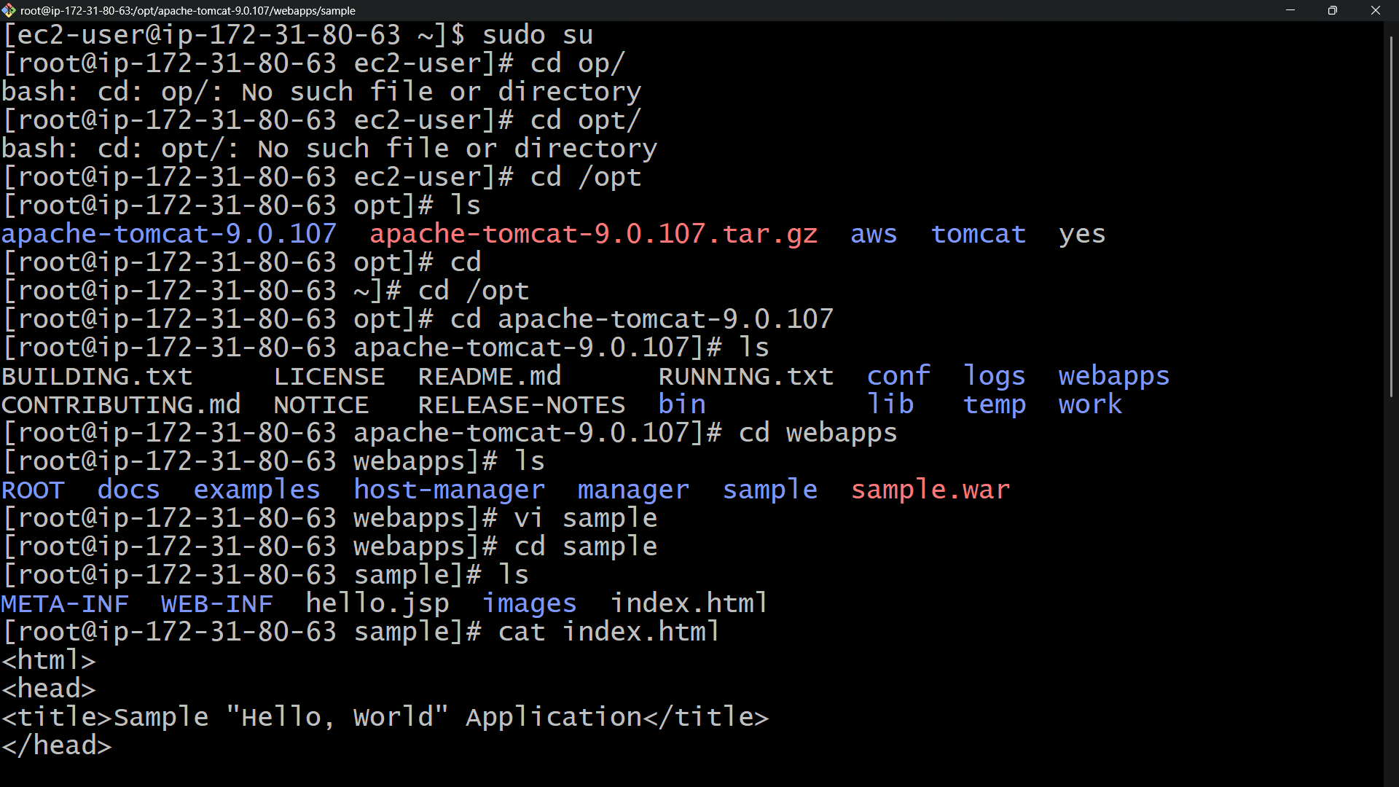

7) Create a tomcat.service file for tomcat.
Create systemd service:
sudo nano /etc/systemd/system/tomcat.service
Add
[Unit]
Description=Apache Tomcat Web Application Container
After=network.target

[Service]
Type=forking

User=root
Group=root

Environment="JAVA_HOME=/usr/lib/jvm/java-11-openjdk-amd64"
Environment="CATALINA_HOME=/opt/tomcat"
Environment="CATALINA_BASE=/opt/tomcat"

ExecStart=/opt/tomcat/bin/startup.sh
ExecStop=/opt/tomcat/bin/shutdown.sh

[Install]
WantedBy=multi-user.target
Enable and start:
sudo systemctl daemon-reload
sudo systemctl enable tomcat
sudo systemctl start tomcat
Check status:
systemctl status tomcat
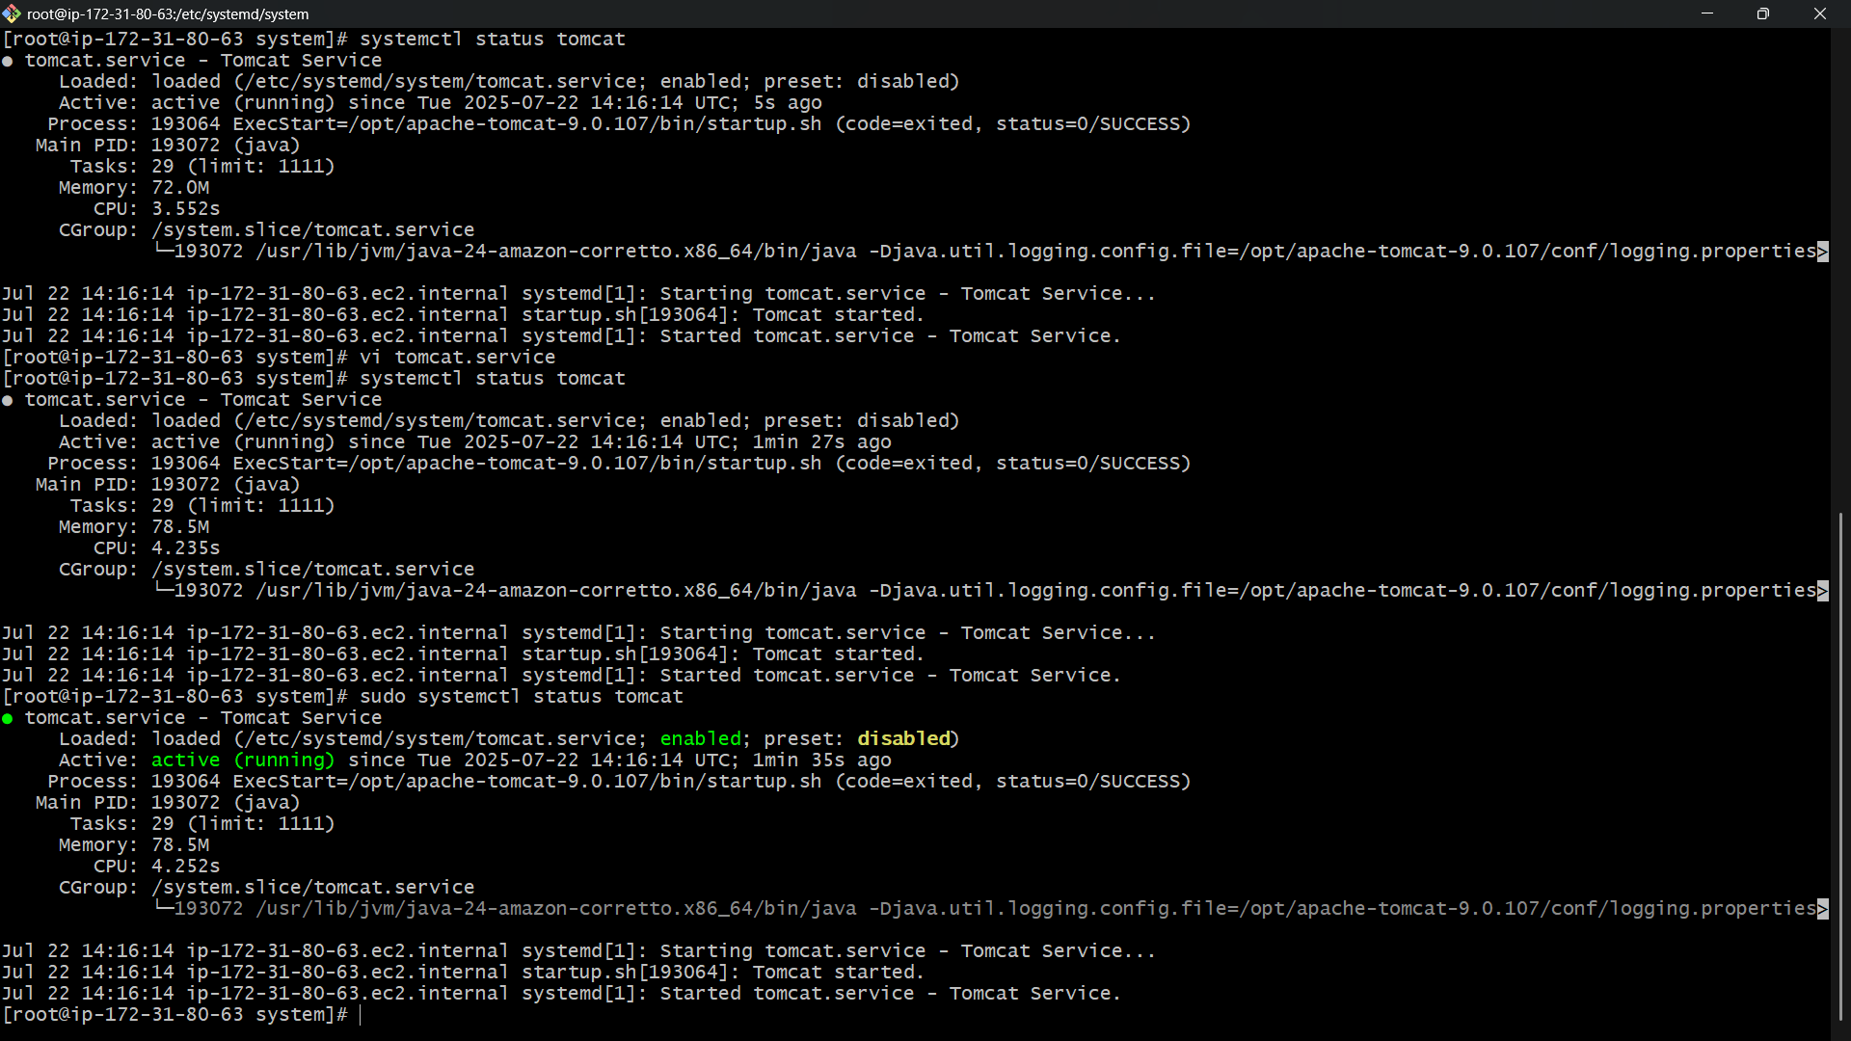
8) Configure HA Proxy server
Install HAProxy:
sudo apt install haproxy -y # Ubuntu
sudo yum install haproxy -y # CentOS
Configure HAProxy:
sudo nano /etc/haproxy/haproxy.cfg
Add at the end:
frontend http_front
bind *:80
default_backend http_back

backend http_back
balance roundrobin
server nginx_server 127.0.0.1:81 check
server apache_server 127.0.0.1:82 check
Restart HAProxy:
sudo systemctl restart haproxy
Check:
http://<server-ip>

